NAVI Series Product Manual

NAVI Series Product Manual

Scope of This Manual
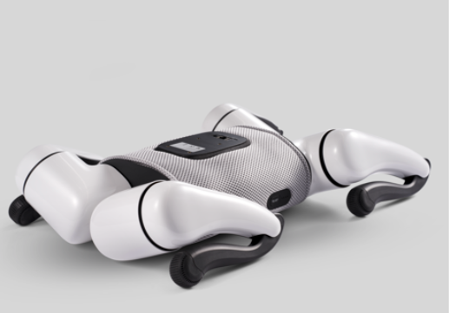

Terminology and Definitions
NAVI
NAVI is the product name of an AI-powered quadruped robot.
Large Language Model (LLM)
A large language model is an AI technology capable of understanding and generating human language. During intelligent voice interaction, it understands your voice input, generates relevant text output, and converts it into speech for interaction.

Product Features and Main Functions
Graphical Programming:
- Includes motion categories, with features continuously updated.
- Program NAVI via the App to create more motion combinations.
Multi-Function Remote Control:
- Supports App-based remote control and fingertip gamepad control.

Component Names
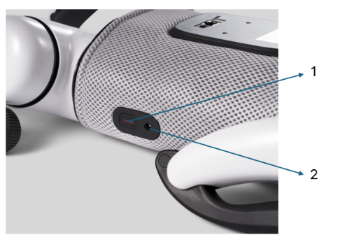
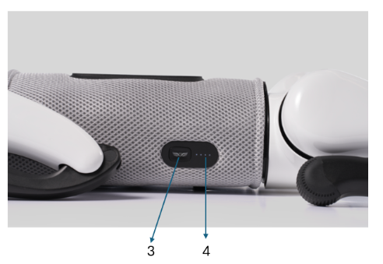

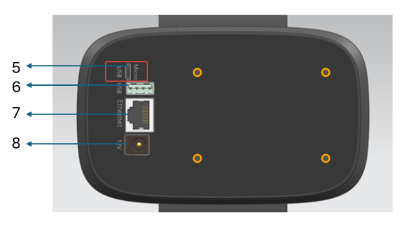

- Emergency stop
- Charging port
- Power switch
- Battery level indicator lights
- Micro USB
- USB
- Ethernet
- Power outlet

Accessories List
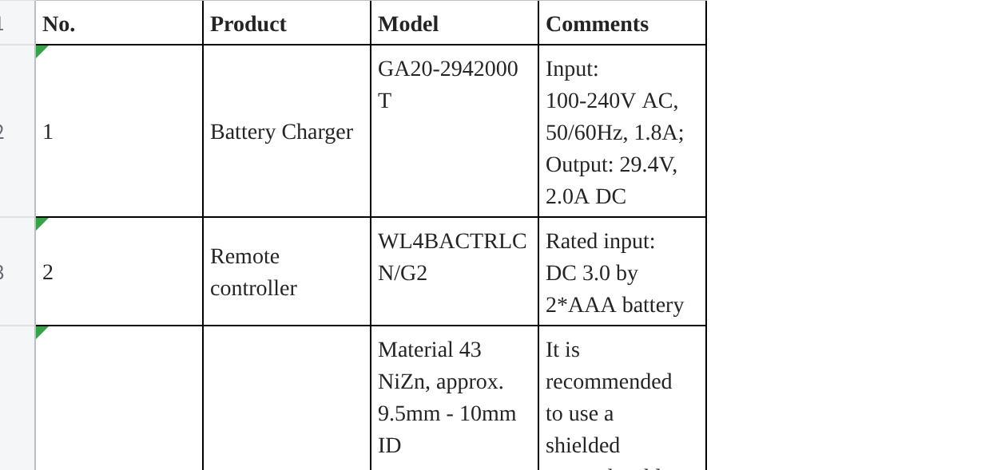
点击图片可查看完整电子表格

Safety Notice
As a safety precaution, users should not remove the protective foam from the exterior of the product.

FCC Compliance Notice
This device complies with part 15 of the FCC Rules. Operation is subject to the following two conditions:
- This device may not cause harmful interference, and
- this device must accept any interference received, including interference that may cause undesired operation.

Please note that changes or modifications not expressly approved by the party responsible for compliance could void the user’s authority to operate the equipment.

RF exposure statement
This equipment complies with radio frequency exposure limits set forth by the FCC for an uncontrolled environment.
This equipment should be installed and operated with a minimum distance of 20 cm between the device and the user or bystanders.
This device must not be co-located or operated in conjunction with any other antenna or transmitter.

Note: This equipment has been tested and found to comply with the limits for a Class B digital device, pursuant to part 15 of the FCC Rules. These limits are designed to provide reasonable protection against harmful interference in residential installations. This equipment generates, uses and can radiate radio frequency energy and, if not installed and used in accordance with the instructions, may cause harmful interference to radio communications. However, there is no guarantee that interference will not occur in a particular installation. If this equipment does cause harmful interference to radio or television reception, which can be determined by turning the equipment off and on, the user is encouraged to try to correct the interference by one or more of the following measures:
—Reorient or relocate the receiving antenna.
—Increase the separation between the equipment and the receiver.
—Connect the equipment into an outlet on a circuit different from that to which the receiver is connected.
—Consult the dealer or an experienced radio/TV technician for help.

Pre-Use Checklist
Before using NAVI, please perform the following routine checks to ensure safe operation:
- Check that NAVI’s battery is sufficiently charged.
- Check that the fingertip remote controller’s battery is sufficiently charged.
- Check that the foot pads on the bottom of NAVI’s feet are intact.
- Check that all four limbs are intact and that the front and rear legs can move freely without obstruction.
- Check that NAVI’s back, chest, and abdomen show no signs of looseness or damage.
- Check that the App runs normally.

Pre-Operation Guidelines
Operator Requirements
NAVI is intended for use by individuals aged 14 and above with appropriate cognitive and behavioral capabilities.
Children under 14, elderly individuals, pregnant women, people with disabilities, and others with health conditions that prevent safe operation should only operate NAVI under the guidance and supervision of an adult guardian or trusted companion.
Pre-Operation Preparation
- Before each operation, check NAVI’s basic status, including battery level, operating condition, and external appearance. If any abnormality is found, stop use and contact official after-sales support.
- If NAVI makes unusual sounds, immediately stop use and contact official after-sales support for professional guidance or repair and inspection services.
- If all charging indicator lights are off after powering on, the battery is low and NAVI may not have sufficient power for normal operation. Please ensure that the battery is fully charged before operating.
- Before lending NAVI to another person, ensure they have read this manual. You are responsible for the safety of new operators; please help them learn the basic operations. Only allow them to operate once they are familiar with the key operating points.
- Do not allow two or more people to control NAVI simultaneously.
- When powered on, do not push, pull, or move NAVI’s limbs, as this may cause hand injuries.
- Please carefully read and follow all “Note,” “Warning,” “Do Not,” and “Avoid” instructions in this manual.

Power On/Off Instructions
Pre-Startup Posture Requirements (Illustrated)
When powered off, NAVI cannot autonomously adjust its joint positions. Therefore, before powering on, you must manually position NAVI’s four limbs into the standard startup posture to ensure it can stand normally after powering on. The standard startup posture is shown below.
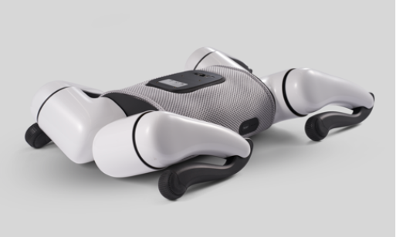

Before powering, ensure NAVI is in the standard startup posture shown above.
Power Button Location
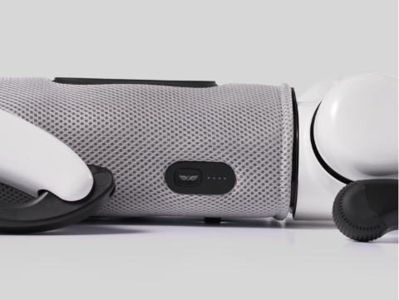

How to Power On
Follow these steps:
Press and hold the power button for 3 seconds. Upon hearing a “humming” tone, release the button to complete the startup. The button light will illuminate, and the battery indicator lights will flash in sequence, displaying the current battery level.
How to Power Off
To ensure NAVI responds flexibly and precisely to shutdown commands, NAVI offers the following two shutdown methods. Please wait until NAVI has completely stopped moving and safely crouched down before shutting off.
*Note: Do not power off while NAVI is moving or standing. Once shutdown is triggered, NAVI will immediately lose power, which may cause personal injury or property damage.
Standard Shutdown
- Press and hold the power button for 3 to 5 seconds; you will hear a long “humming” tone.
- Release the button after the tone; NAVI will automatically shut down once all indicator lights go off.
Force Shutdown
*Note: Use this only when standard shutdown cannot be completed.
- Press and hold the power button for more than 6 seconds.
- Release after all indicator lights go off; NAVI will force shut down.
Accidental Power Button Activation
When No Pre-Startup Preparation Is Needed
When NAVI has crouched down due to a depleted battery, it can autonomously adjust its joint positions, so no limb adjustment is needed before powering on.

Unboxing Guide
Packing List
To ensure a quality user experience, please carefully check the contents of the box upon first opening.
*Note: If any items are missing from the package, please contact our customer service team promptly. We will do our utmost to resolve the issue and help you start your journey with NAVI as soon as possible.
Quick Unboxing
Each step below is designed to help you easily get NAVI up and running and fully enjoy this innovative experience. Whether you are a tech enthusiast or new to smart products, we believe following these steps will let you get started quickly and dive right into interacting with NAVI.
Before Unboxing
- Please scan the QR code below to download the NAVI App — TO BE UPDATED
*Note: For best results, we recommend scanning the QR code above using a browser to download the NAVI App. Currently only Android and iOS mobile operating systems are supported.
Unboxing Steps

Unboxing Troubleshooting
NAVI fails to power on (button light turns on then goes off)
Incorrect startup method — Press and hold the power button for 3 seconds; release after hearing the “humming” tone to complete startup.
NAVI fails to power on (button light turns on then quickly goes off)
Button pressed too frequently — Wait 5 seconds, then restart following the instructions.
NAVI fails to power on (button light does not turn on / turns on then goes off / stays on but battery indicator does not light)
Insufficient battery — Remove the charger from the accessory box and charge NAVI for approximately 90 minutes.
Incorrect static posture — Lay NAVI’s limbs flat, correct the posture, and restart.
Powering On Outside the Box
If you are starting NAVI outside the box, please observe the following pre-startup conditions.
Hard and Level Surface
The surface should not visibly indent under pressure. Avoid starting on uneven surfaces or overly soft carpets.
No Obvious Obstructions on the Surface
There should be no visible obstructions or protrusions on the surface contacting NAVI’s legs and belly. Avoid items such as cardboard or children’s toys that may affect NAVI’s static posture.
Lower Legs Folded to Structural Stop
Deviation of up to 18° is acceptable. The lower legs should be in close contact with the upper legs.
Hip Joint Actuator Angle Requirements
The hip joint and thigh angle deviation should be within 18°. Adjust the thigh and hip joint angle so that both the foot pads and knee joints flush with the ground.

Activation
Users can bind NAVI by scanning the activation of QR code to become an administrator. Administrators can share NAVI with other members.
Activation Steps
- After downloading the NAVI App, open it and log in to your account.
- On the App home screen, tap “Click to pair.”

Network Settings
Connecting to the Robot Dog Hotspot via App
The App will automatically connect to the robot dog hotspot by default. If autoconnection fails, follow these steps:
- Confirm that the robot dog is activated and powered on.
- If you have multiple robot dogs, go to “Pet” in the top-left corner of the App home screen and select the target robot dog under “Switch Pet.”
- Tap the “Pair” button on the App home screen; the App will connect to the robot dog hotspot.
Troubleshooting
If pairing fails after tapping “Pair,” manually connect to the robot dog hotspot as follows:
- On the App home screen, go to General > Wi-Fi & Security > Copy Password.
- In your phone network settings, select the robot dog Wi-Fi, paste the password, and connect to the robot dog hotspot.
Configuring Wi-Fi for the Robot Dog via App
- Confirm that the App is connected to the robot dog hotspot.
- Tap “Network Connection” on the App home screen to enter the network configuration page.
- Select the target Wi-Fi, enter the password, and tap “Confirm” to complete the setup.
Troubleshooting
During setup, scanning the Wi-Fi list may cause your phone to disconnect from the robot dog hotspot, prompting “Network configuration complete, please check connection shortly.” Reconnect to the robot dog hotspot and configure Wi-Fi again.
Using the Robot Dog’s 4G Network
- If you have not paired a pet in the App, the robot dog’s 4G network is used by default. We recommend configuring Wi-Fi for the pet after pairing.
- If the connected Wi-Fi signal is weak, you can switch to 4G in the App’s home screen under Network Connection.

User Guide
Direct Wired Charging:
NAVI is equipped with a charging port for convenient direct charging. This method is especially useful when NAVI’s battery is completely depleted, and it cannot move on its own. Direct charging offers the highest efficiency among all charging methods and is easy to operate. Regardless of your environment, using the FF-provided charging kit can quickly replenish NAVI’s power for continuous efficient operation.
Understanding Charging and Operating Status via Indicator Lights
Indicator Light Meanings
White Battery Indicator Lights:
Used to display current battery level and charging progress while charging.
Dual-Color Charging Indicator Light:
Indicates charging status: charging, fully charged, or discharge.
*Note: Use the following dual-color charging indicator light colors to determine NAVI’s charging status: Yellow — currently charging; White — fully charged; Off — charger unplugged, NAVI operating normally.
Operating Mode Indicator Light Status
Charging Mode Indicator Light Status
*Note: NAVI is equipped with 4 battery indicator lights to show the remaining battery level. The battery is divided into 4 equal sections, allowing you to quickly assess the approximate remaining power. Additionally, NAVI is equipped with an automatic charging station / Little World; when the battery is low, NAVI will autonomously go to the charging station / Little World to charge.

Fingertip Remote Controller Instructions
The fingertip remote controller is an innovative single-hand line-of-sight remote control product designed to provide an exceptional robot control experience. NAVI is equipped with advanced robotic joints for superior and responsive movement. Using this single-hand controller, you can control NAVI with flexibility and speed, delivering a uniquely enjoyable remote-control experience.
Button and Function Description
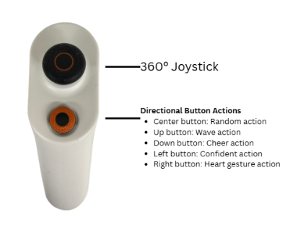
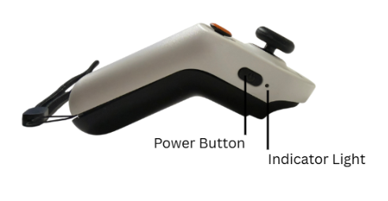

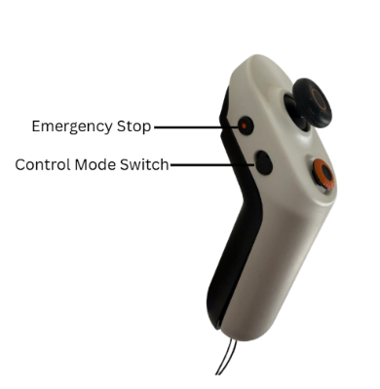

Initial Pairing Method
STEP 1:
Keep NAVI and the fingertip remote controller within 1 m of each other.
STEP 2:
When the controller battery has power and the controller is powered off, press and hold the right-side power button for 5 seconds.
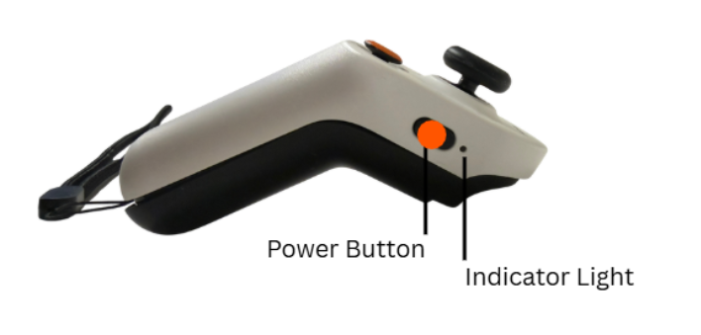

STEP 3:
When the blue LED changes from fast flashing to steady on, the connection is successful.
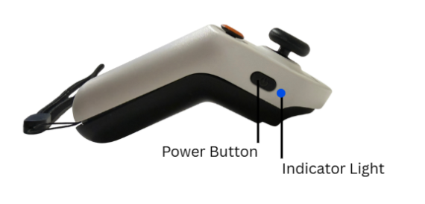

Daily Use
After the initial pairing, the fingertip remote controller will automatically remember NAVI’s device information. Subsequently, each time you turn on the remote controller, as long as you are within 5 m of NAVI, the controller will automatically connect without requiring pairing again. You can directly use the controller to control NAVI’s movements.
Fingertip Remote Controller Specifications
*Note: The effective control range of the fingertip remote controller is within 5 m; in open areas, range can reach 10 m. Nearby moving people or metal obstacles will significantly affect signal transmission and may cause disconnection. Once the distance meets the minimum communication range, the controller will automatically reconnect to NAVI.

Technical Specifications
Physical Parameters: Dimensions, Weight, etc.

Safety and Legal Information
Safety Warnings for Regular Use and Maintenance
Legal Disclaimer
- Before using the robot dog, please carefully read this manual and operate the robot dog in accordance with its contents.
- The robot dog is intended for independent use only by individuals aged 14 and above with appropriate cognitive and behavioral capabilities (see the Operator Requirements section of this manual for details).
- For privacy-related matters, please refer to the NAVI Privacy Policy and the End User License Agreement, and read them carefully.
- The robot dog shown in this manual is intended to guide users on how to correctly and fully experience the robot dog. The color and appearance of the robot dog shown in images/videos may differ from the product you purchased. Please refer to the actual product received.
- To continuously improve product functionality and your user experience, the robot dog will be regularly upgraded and optimized. The electronic version of this user manual will be updated periodically on the official website and App. You may check for the latest version at any time.
- Users must comply with local laws and regulations when using the robot dog. The robot dog must not be used to harm other people or animals, or be modified as a weapon, as this may result in the loss of product warranty and other customer rights.
Precautions
- To reduce the risk of injury, always check NAVI’s operating status before use.
- Start NAVI on flat ground. Do not suddenly accelerate or decelerate, as this may cause loss of control or collision.
- Stay alert during operation. Keep NAVI and its activity area within your line of sight to avoid collisions with people or objects.
- Operate NAVI at an appropriate speed. Always maintain a safe distance from other moving people or objects. Slow down when entering unfamiliar environments.
- To avoid distraction, do not wear headphones, earbuds, take calls, take photos, or engage in activities unrelated to operating NAVI while doing so, in order to properly observe the surroundings.
- Exercise caution when operating NAVI in low-visibility environments to avoid personal injury or property damage.
- Do not operate NAVI on slippery surfaces such as ice or glass.
- Do not operate NAVI on elevated surfaces such as tables or beds, or in confined spaces, to avoid falls and injuries.
- Slow down when making turns to avoid NAVI losing control.
- Do not operate NAVI when any component is damaged.
- Do not interfere with NAVI’s normal operation to prevent personal injury.
- Do not ride on NAVI, as this may cause personal injury or property damage.
- Do not place heavy loads on NAVI, as this may cause personal injury or property damage.
- Do not modify or disassemble NAVI without authorization.
- Do not replace or install parts using non-original accessories.
- Do not install third-party components on your own, as this may cause compatibility and reliability issues.
- Prevent NAVI from being submerged in liquid, ingesting foreign objects, contacting chemical substances, or being scratched, as these will cause damage.
- Do not clean NAVI using high-pressure water jets or hoses, as water may enter and damage the battery, circuit chips, and other components.
- If NAVI has been caught in rain or water has entered the device, immediately stop use, do not power on, and contact after-sales service promptly.
- Do not perform any operations beyond wiping NAVI dry, as improper handling may cause further damage or void the warranty.
- Avoid leaving NAVI unpowered for extended periods, as this may degrade battery performance.
- Do not repair components, modify circuits or battery packs, or misuse the charger on your own.
- Do not operate NAVI in areas with complex electromagnetic environments or strong interference sources such as mines, transmission towers, high-voltage lines, substations, or nuclear radiation zones, to avoid interference with NAVI’s wireless control.
- This product does not support the use of third-party applications.
- Do not use any unofficial system channels or updates, as this may introduce security risks.
If you violate the above instructions when using NAVI, it may cause damage to NAVI itself or to your or others’ personal safety and property. It may also result in the loss of your right to free after-sales service during the warranty period. For specific after-sales policies, please refer to the After-Sales Service Policy.

Maintenance and Care
Usage Care
Post-Operation Care
- Stop NAVI on a relatively flat surface before powering off.
- Always use the original charger to prevent battery damage or fire risk.
Parts Requiring Regular Maintenance or Replacement
Main Unit Maintenance
- Check that all parts of NAVI are in good condition. If in doubt, contact the after-sales service team.
- Before performing maintenance or cleaning, ensure NAVI is powered off and the power adapter is disconnected.
- When replacing accessories, use manufacturer-specified parts to avoid damage caused by incompatibility.
- The foot pads are consumable parts. Severe wear, missing corners, or detachment may cause NAVI to move or stand unstably.
- Regularly check battery level and health. When battery life noticeably decreases, contact customer service for a battery replacement.
- Store NAVI and the power adapter in a cool, dry place.
Battery Maintenance
- Never store the battery in an environment where the temperature exceeds 45°C or falls below -10°C. Long-term storage under such conditions will degrade battery performance.
- For long-term storage (more than 3 months), store the battery at 20°C to 25°C with a relative humidity of 0 to 60% RH. The battery charge should not exceed 80%; 30% to 50% is recommended.
- During storage, periodically check the battery level. If it drops below 20%, recharge the battery. It is recommended to recharge at least once every 3 months to maintain battery activity.
- The recommended charging temperature for the battery is 10°C to 25°C.
- Do not charge the battery for more than 24 hours, as overcharging will shorten battery life.
- After under-voltage protection is triggered, the battery cannot output power; it must be charged before normal operation can resume.
- Avoid deep discharge of the battery, as this may permanently disable it and make it unable to charge again.
- The battery will automatically stop charging when fully charged. It is recommended to disconnect from the charger after fully charged.

Troubleshooting
Common Issues and Solutions
My original fingertip remote controller broke and I bought a new one. How do I connect it to NAVI?
The new fingertip remote controller has not been paired with NAVI. For the first connection, you need to put the fingertip remote controller into pairing mode to establish a connection with NAVI. For the specific steps, refer to the “Initial Pairing Method” section of this manual.
When controlling NAVI with the fingertip remote controller, NAVI moves very slowly. How do I make it faster?
The fingertip remote controller has a high-speed mode and a low-speed mode; low-speed mode is the default. To increase speed, press the speed toggle button to switch modes. After increasing speed, please adapt gradually and avoid pushing the joystick too aggressively to prevent collisions.
The fingertip remote controller worked well at first, but sometimes it stops responding and then recovers after a moment.
The effective control range of the fingertip remote controller is 5 m, and up to 10 m in open areas. Nearby moving people or metal obstacles will significantly affect signal transmission and may cause disconnection. Once the distance meets the minimum communication range, the controller automatically reconnects to NAVI. For best results, use in open areas within 10 m.

Help
If you encounter any problems or need assistance during use, you can contact us at any time through the following channels:
Website: www.ff.com
Email: sale@ff.com
If you have any feedback or suggestions about the robot dog, we warmly welcome you to share them with us. Your understanding and support are the driving force behind our progress.
For detailed after-sales policies, please visit the official website. For more detailed usage instructions, please refer to the in-App guide.

Responsible AI & Robotics Use Guidelines
This product is designed to support learning, creativity, robotics exploration, and supervised educational use. To ensure safe and responsible use, please follow the principles below:
- Human Supervision Required
The robot and AI features are learning tools. A responsible adult, teacher, or trained operator should supervise use, especially when used by children, students, or in public environments.
- AI Transparency
Users should be clearly informed when they are interacting with AI-generated responses, AI-assisted features, or autonomous robot behaviors.
- Child Safety First
When used by minors, especially children under 13, the product should be used with parent, guardian, teacher, or institutional supervision. Age-appropriate settings, privacy controls, and safer-by-default configurations should be applied.
- Use Only for Intended Purposes
The product should only be used for approved educational, demonstration, development, or operational scenarios. It should not be used to provide medical, legal, psychological, financial, or emergency advice.
- Data Minimization
Collect and retain only the data necessary for product operation, learning progress, safety, troubleshooting, and authorized educational purposes. Avoid uploading or sharing unnecessary personal information.
- No Manipulative Use
The product should not be used to manipulate users, create emotional dependency, encourage excessive engagement, or pressure users into unwanted actions.
- Explainable and Reviewable Actions
Important AI-assisted outputs, recommendations, scores, or flags should be reviewable by a human supervisor. AI-generated content should not be treated as final without appropriate review.
- Physical Safety Boundaries
Keep a safe distance from moving parts. Use emergency stop features where available. Do not operate the robot in a way that may cause injury, collision, property damage, or unsafe interaction with people or animals.
- Fair and Respectful Use
The product should be used in a way that respects all users and avoids discriminatory, harmful, harassing, or biased interactions.
- Content and Intellectual Property Respect
Users should respect copyright, trademarks, and third-party content rights when uploading, creating, or sharing course materials, media, code, or robot projects.
- Accuracy and Limitations
AI-generated information may be incomplete or inaccurate. Users should verify important information through trusted sources and should not rely on AI outputs for high-stakes decisions.
- Consent and Privacy
Obtain appropriate consent before recording, uploading, sharing, or processing images, voice, video, personal data, or student information.
- Human Override and Reversibility
Robot actions and AI-assisted outputs should be controllable, stoppable, and reviewable by a human operator whenever possible.
- Responsible Operation
Use the product in a safe, ethical, and environmentally responsible manner. Follow all instructions, warnings, applicable laws, school policies, and organizational rules.

